Git Challenges
1. Resolve Merge Conflicts
Create a merge conflict intentionally (two users editing the same line).

- Create file core in main branch and feature branch

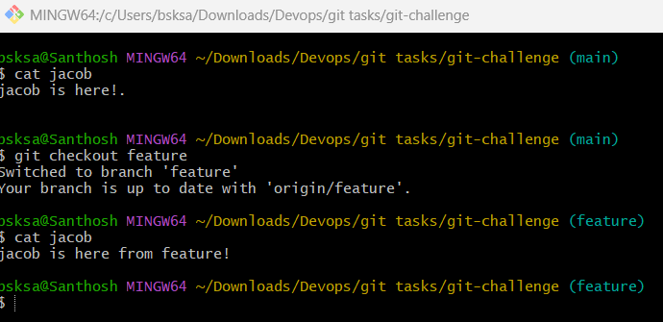

Resolve the conflict and push the changes.

- Switch to feature branch
- Use git merge main
- Notice that the merge conflict is displayed
- Edit the core file
- Add to tracking git add .
- Commit the changes.
- push to repo git push -u origin
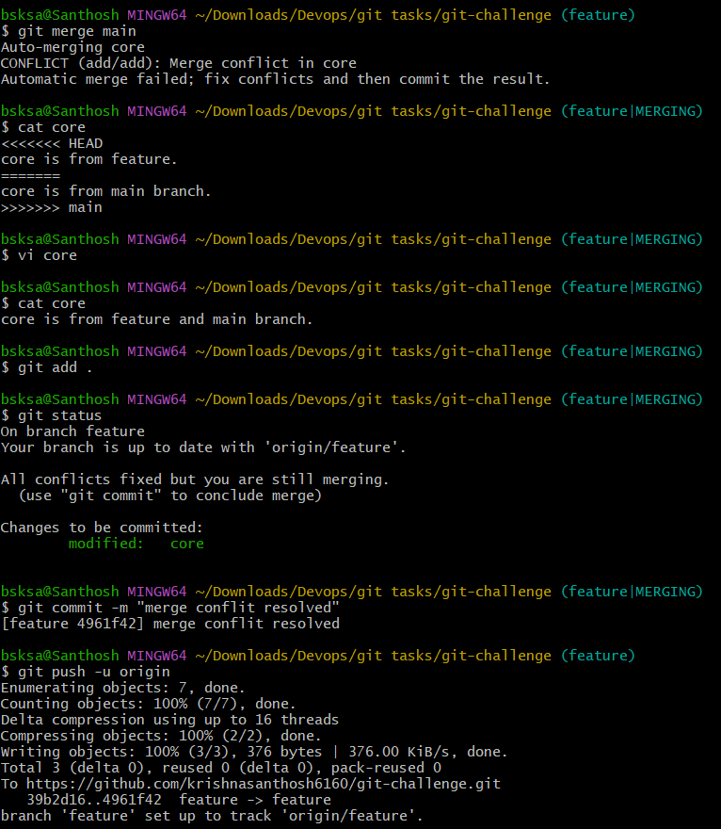

2. Recover Deleted Branch
Delete a local branch and then recover it using the reflog.

- git branch -d feature
- git reflog
- git branch -b feature commit id

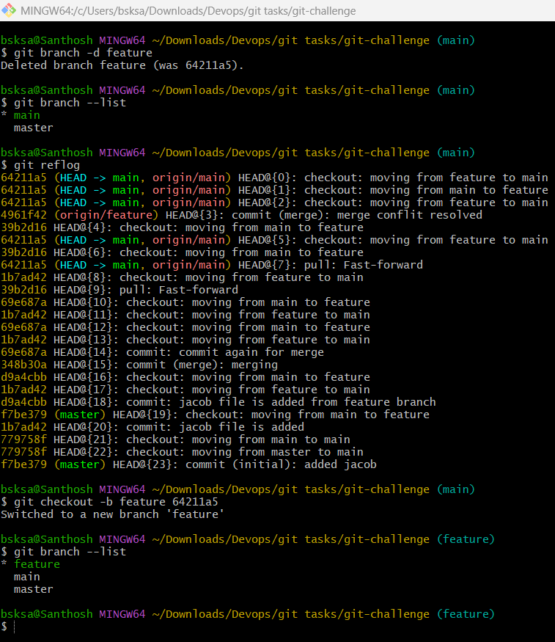

3. Undo Wrong Push
Push a wrong commit to GitHub, then undo it without losing history.

- Add a file abcd
- Add to tracking git add .
- Commit git commit -m “added abcd file”
- Revert the wrong commit git revert commit ID
- Check log for reference git log -2

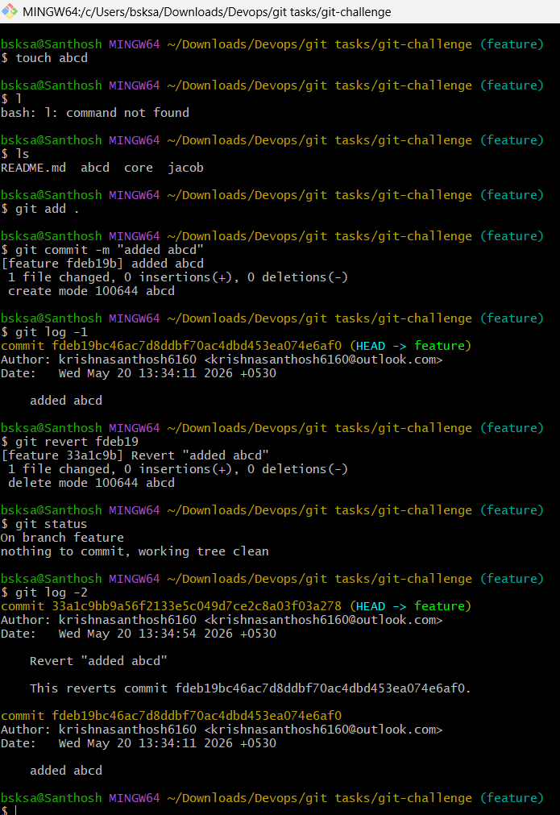

4. Amend a Commit
Make a commit, then add a missing file to it using git commit --amend.

- Add files fida gida and commit it with message.
- echo "Forgot this file" > tada
- git add tada
- git commit --amend --no-edit
- git show --name-status HEAD
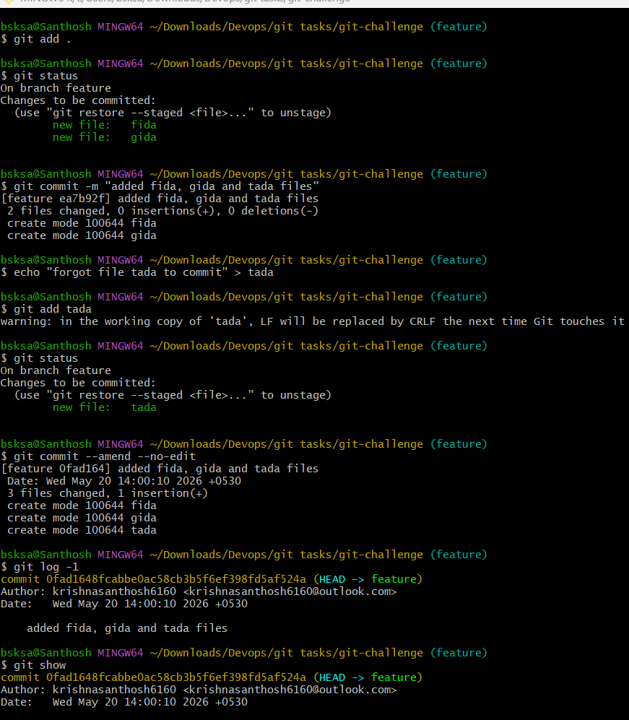

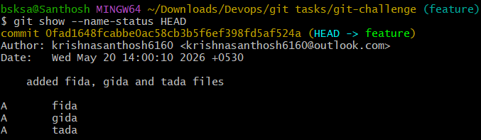

5. Cherry-pick a Commit
Take a specific commit from one branch and apply it to another branch.

- Note a commit id which is to be committed for another branch.
- Change the branch on which the commit to be made git checkout main
- Cherry pick a commit with commit ID git cherry-pick commitID
- Notice that the commit is applied to the main branch

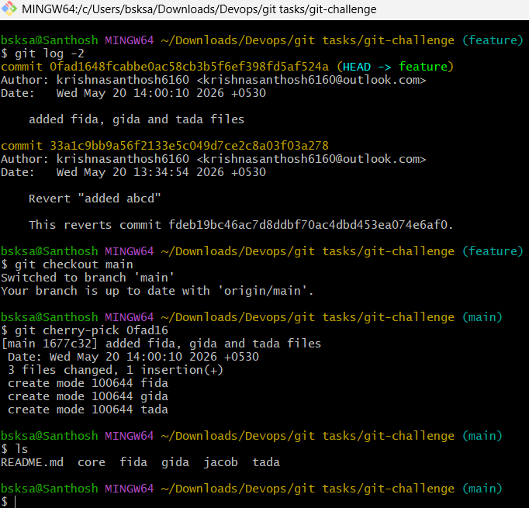

6. Interactive Rebase
Reorder and squash multiple commits into a single clean commit.

- git log to check commit logs.
- To reorder and squash multiple commits git rebase -i HEAD~n
- Reorder and change the commands to pick/squash/reword/edit/fixup
- Save and quit the file.
- Do git log
- Observer that the multiple commits are into a single commit.

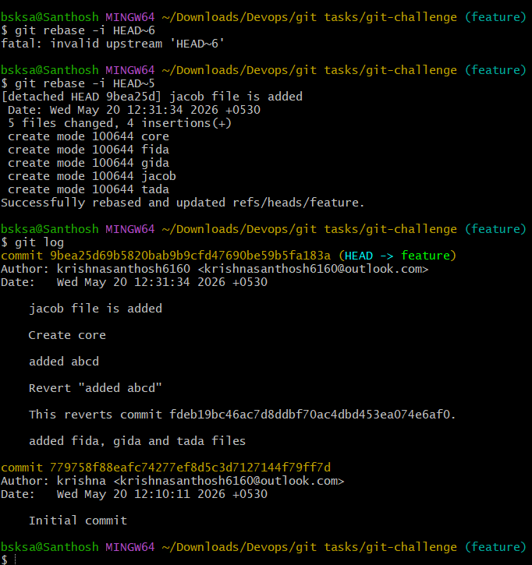

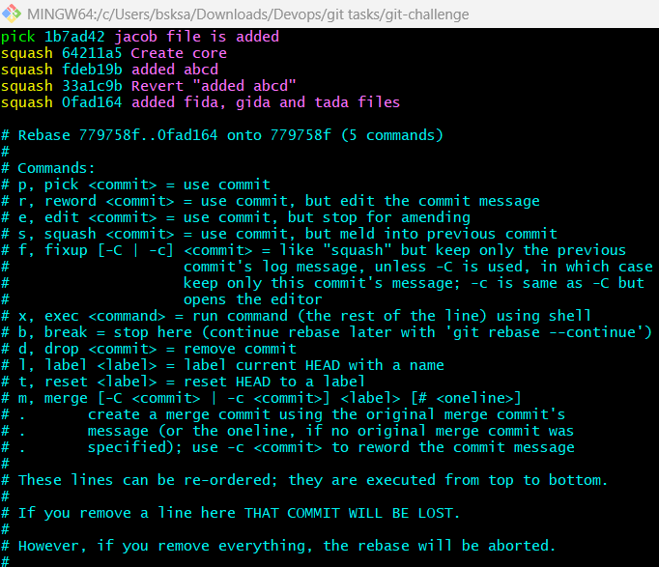

7. Tagging & Release
Create a version tag (v1.0), push it to GitHub, then delete and restore it.
- Create a tag git tag v1.0
- Push a tag git push origin v1.0
- Delete a tag git push origin --delete v1.0
- Restore a tag git tag v1.0 commit ID
- Again, push to github git push origin v1.0
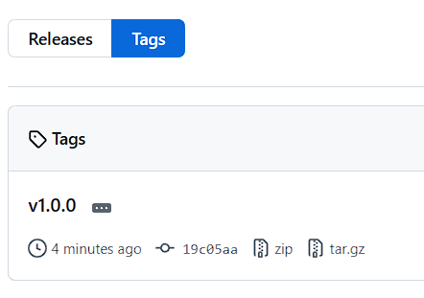

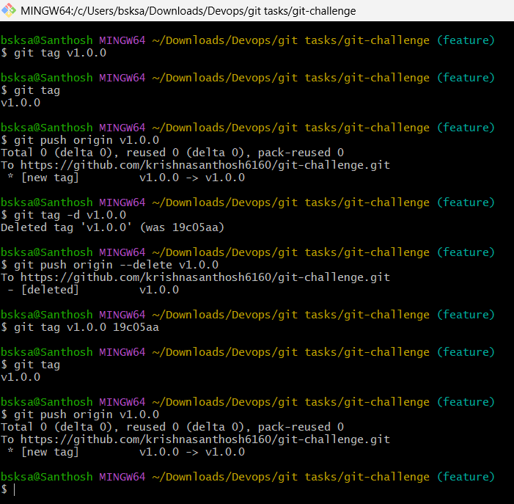

8. Clone with Sparse Checkout
Clone only a subdirectory of a repo using sparse checkout.

- git clone --no-checkout https://github.com/user/project.git
- cd project
- git sparse-checkout init
- git sparse-checkout set subdirectory-name
- git checkout main
- git sparse-checkout list

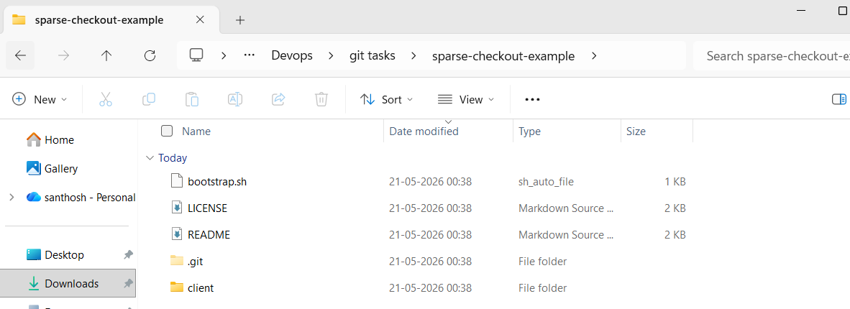
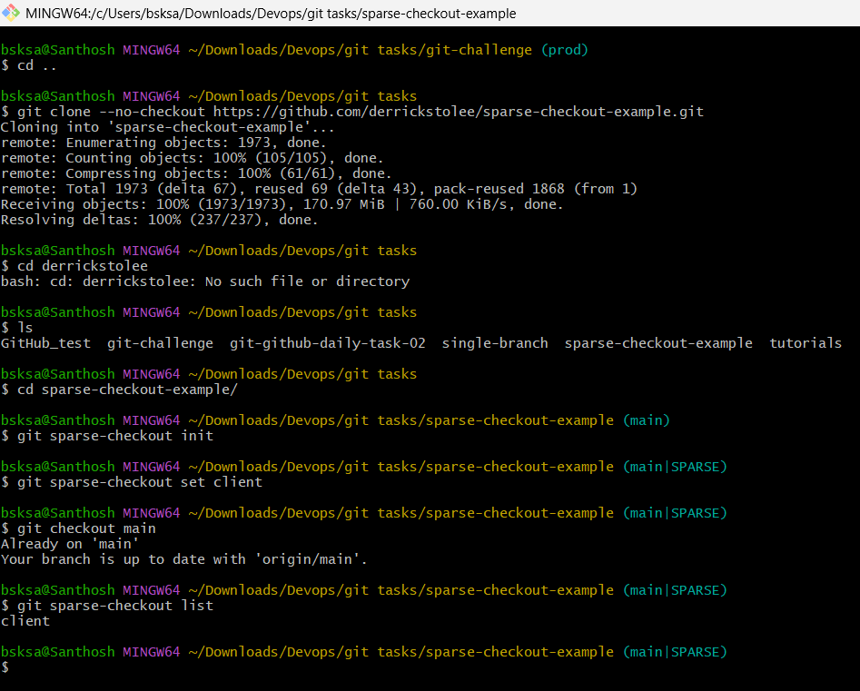

9. Reset vs Revert Challenge
Demonstrate the difference between git reset –hard and git revert in a repo.

- Create a file core and push to repo
- git log –oneline
- git revert 5a84806
- observe that core file is deleted locally
- push to repo git push -u origin
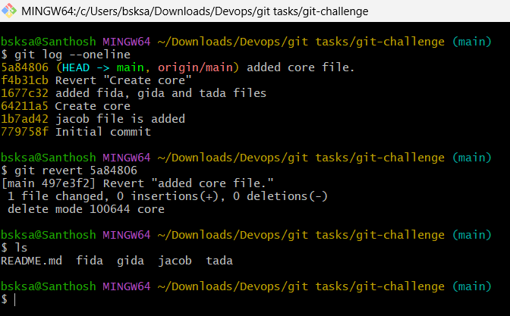

- git reset - - hard HEAD~1
- Moves the HEAD pointer and discards all changes in the working directory and staging area

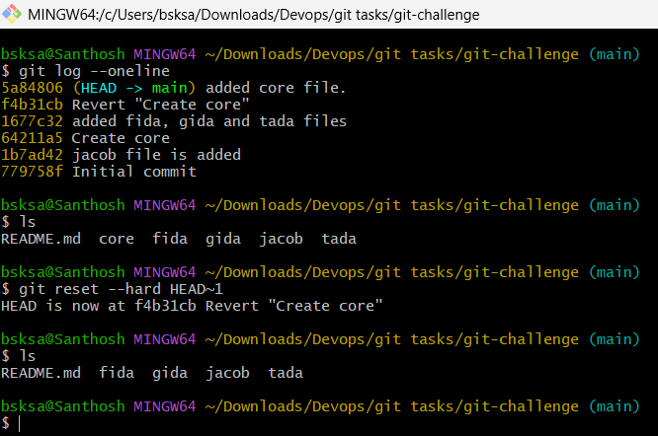

10. Detached HEAD Challenge
Checkout a specific commit (detached HEAD state) and create a new branch from it.

- Check the logs git log –oneline
- List files to check
- To detach head state git checkout commit ID
- Notice that you are in ‘detached HEAD’ state.
- Create new branch git checkout -b release
- Release branch is created.
- Check the current branch git branch
- Observe that commit ID related files/data is available in release branch.

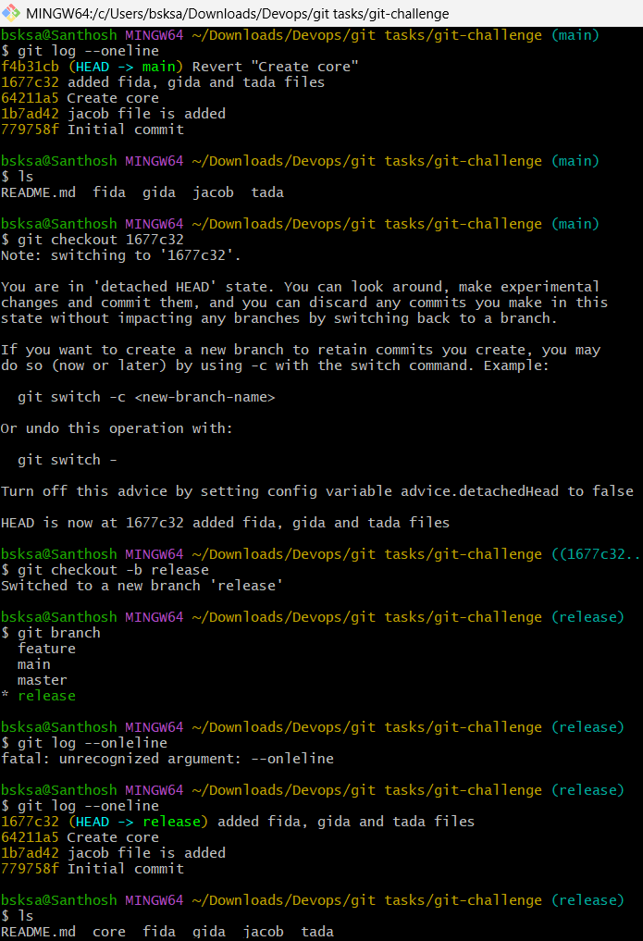

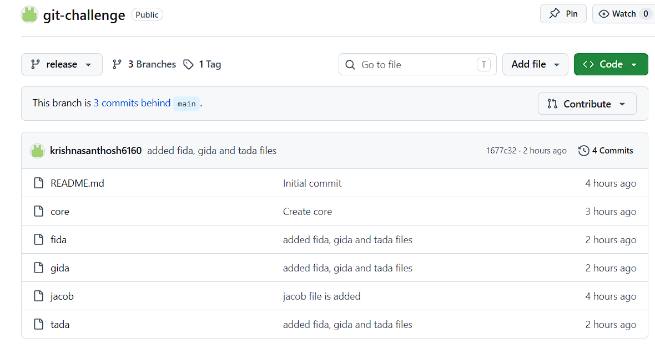

11. Git Hooks Challenge
Configure a pre-commit hook to reject commits without a message format (e.g., must start with JIRA-XXX).

- cd .git/hooks
- vi pre-commit
- Add script
- Make it pre-commit as executable file chmod +x pre-commit

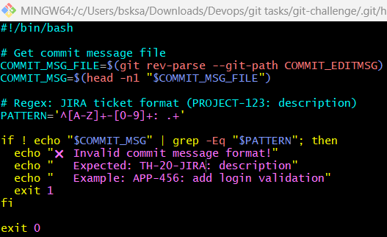

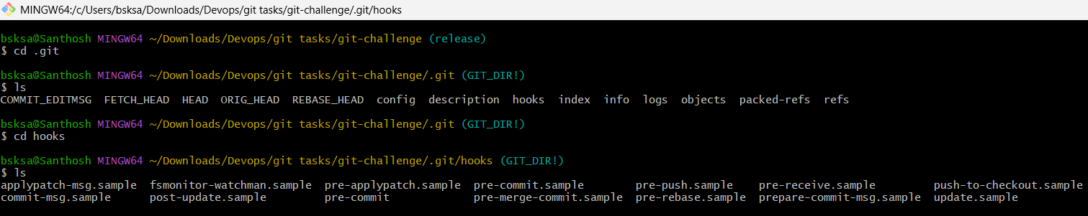

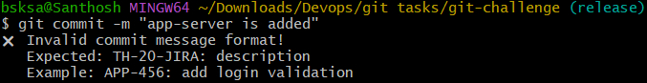

12. Squash Merge vs Rebase Merge
Show the difference between squash merge and rebase merge with evidence.

- Create 3 different commits on release branch
- Switch to main branch git checkout main
- Squash merge the release branch git merge –squash release
- Pulls all changes from release into main.
- Condenses Commits all into a single set of changes.
- Stages these changes in the working directory (but does not commit them).

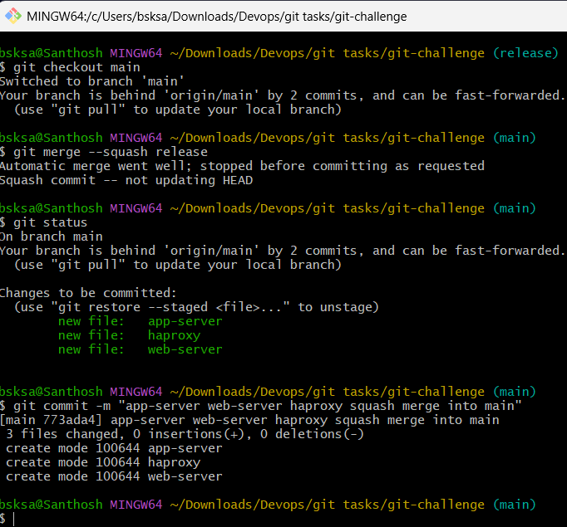

- Add a commit on main branch
- Switch to release branch
- git rebase main
- Temporarily “unwinds” your release branch’s commits (app-server, web-server, haproxy).
- Applies main’s latest commit (servers) to your release branch.
- Reapplies your feature commits (app-server, web-server, haproxy) on top of servers, creating new commits.
- Merge the rebased release branch into main
  - Now that release branch includes main’s latest changes servers and has a linear history, switch back to main and merge

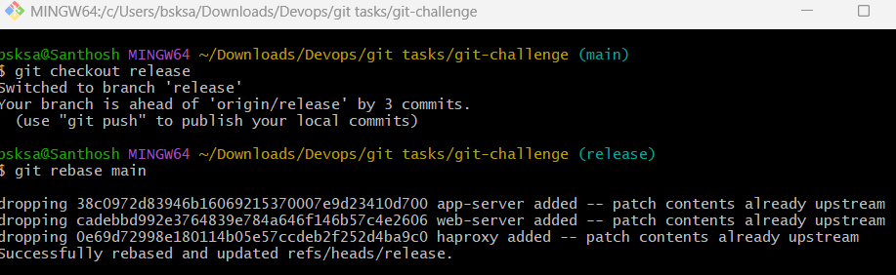

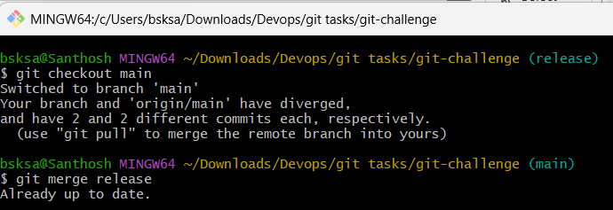

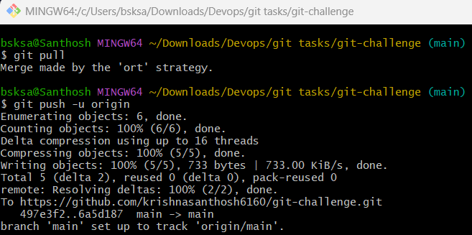

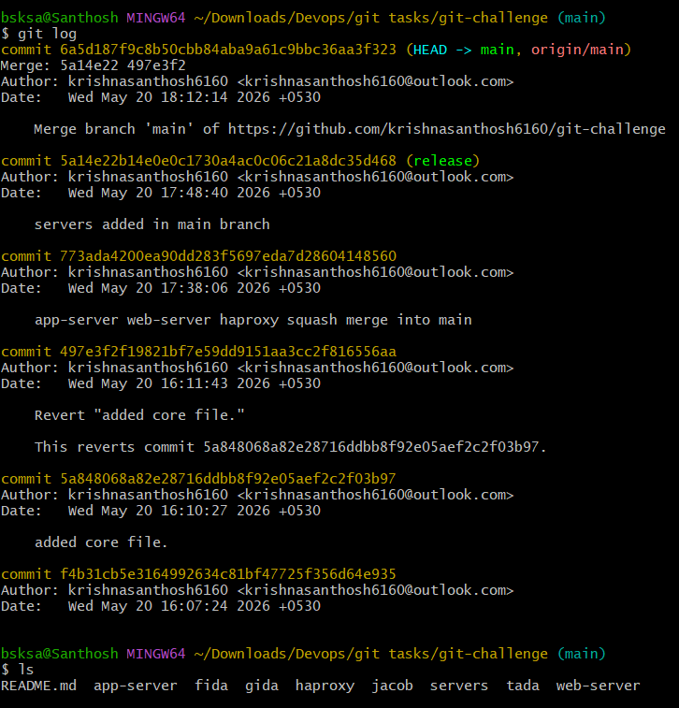

13. Fork & Pull Request Workflow
Fork a repo, make a change, and submit a pull request to the original repo.

- Go to the repository on GitHub.
- Click the Fork button (top‑right corner).
- This creates a copy under your GitHub account

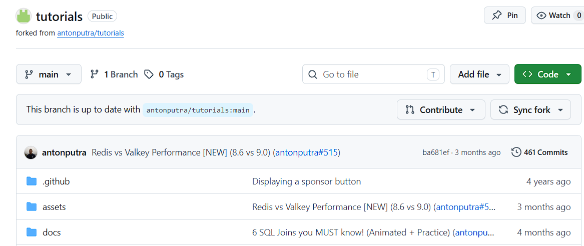

- Clone Your Fork Locally: git clone https://github.com/your-username/repo-name.git
- cd repo-name
- Create a New Branch: git checkout -b feature-branch
- Make Your Changes:
  - Edit files as needed and
  - Add new code, fix bugs, or update documentation.

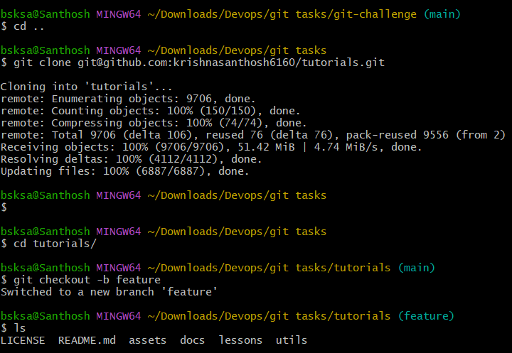

- Stage & Commit Changes:
  - git add .
  - git commit -m "FEATURE: describe your change here"
- Push Changes to Your Fork: git push origin feature-branch

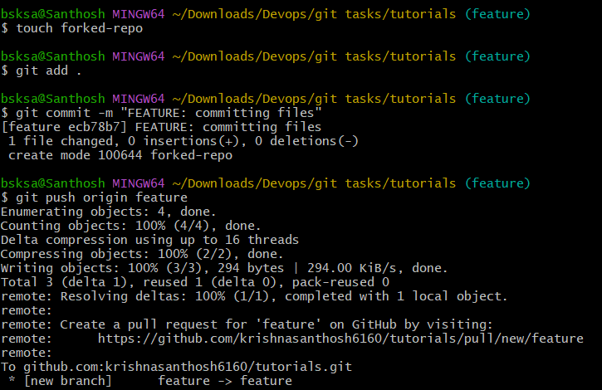

- Open a Pull Request:
  - Go to your fork on GitHub.
  - You’ll see a banner suggesting you to open a PR.
  - Click Compare & pull request.
  - Fill in details (title, description, context).
  - Submit the PR to the original repo.

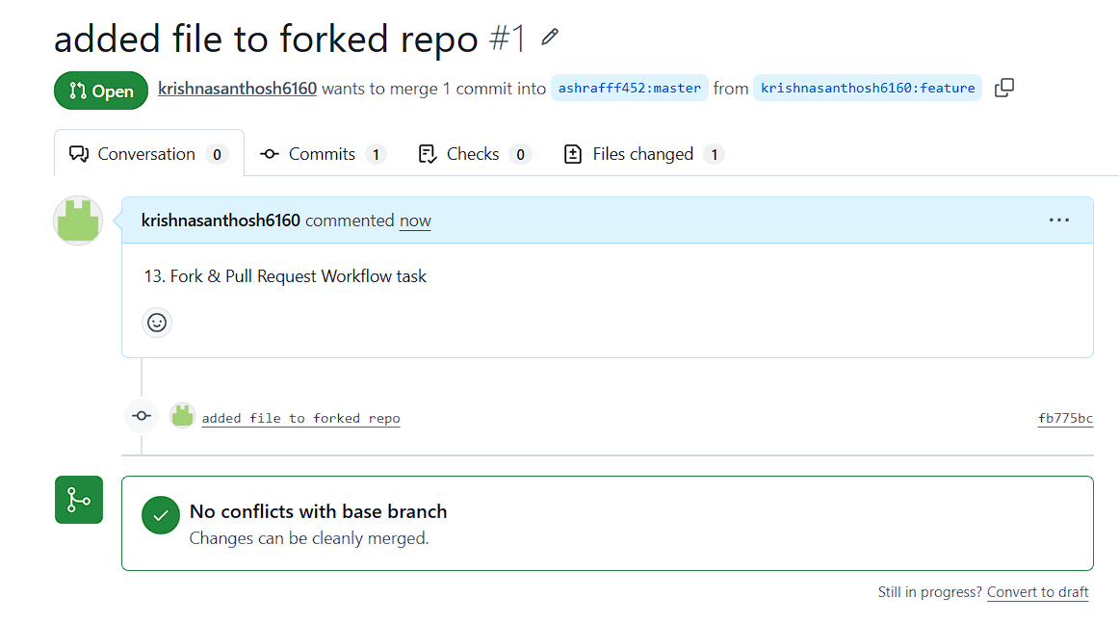

14. Recover Lost Commit
Commit something, reset hard, and then recover it using git reflog.

- Create a file and insert data to the file.
- Git add .
- Git commit -m “initial commit”
- Again append text to the same file and commit with “second commit” as message
- Again append text to the same file and commit with “third commit” as message
- git reset --hard HEAD~1
- notice that the head is pointed to the second commit and undone the third commit.
- Go to git log and observe that the third commit is lost
- git reflog – notice that the head is pointing towards second commit hash code.
- Git reset --hard “third commit hash code”
- Git log – notice that the third commit is visible.
- Even in reflog the head is pointed to third commit hash code.

